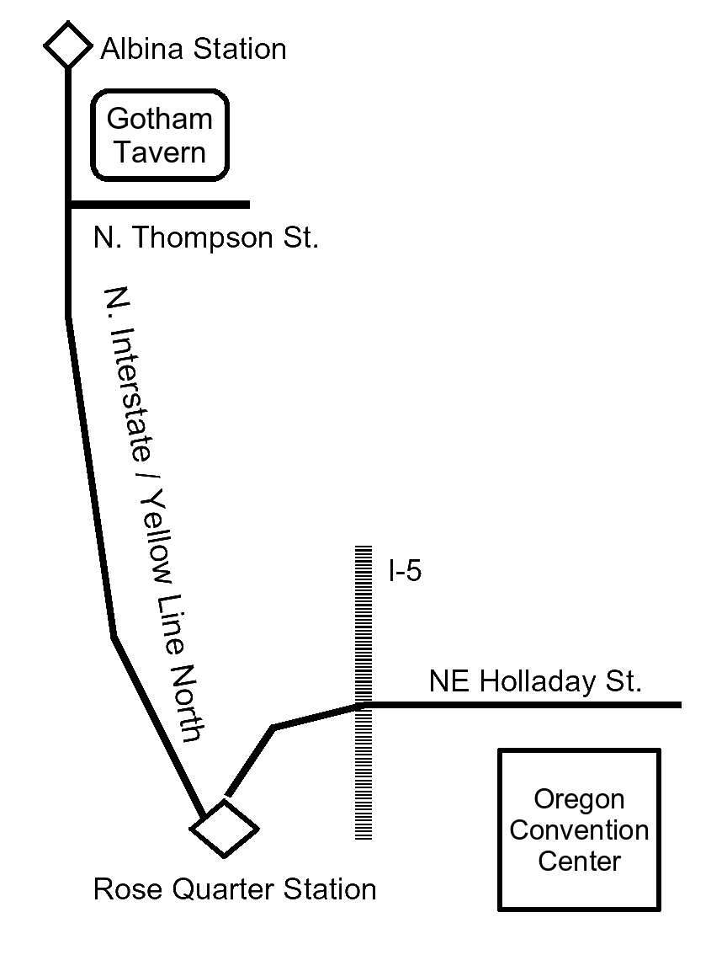
Gotham Tavern
Walk West from the Convention Center to Rose Quarter Station. Take the Yellow Line North. Get off at Albina Station, backtrack to N. Thompson. Gotham Tavern is at the corner.
Drive NE Multnomah to N. Interstate, turn right, take N. Interstate north to N. Thompson.
(503) 517-9911
www.gothamtavern.com
Gotham Tavern
Walk West from the Convention Center to Rose Quarter Station. Take the Yellow Line North. Get off at Albina Station, backtrack to N. Thompson. Gotham Tavern is at the corner.
Drive NE Multnomah to N. Interstate, turn right, take N. Interstate north to N. Thompson.
(503) 517-9911
www.gothamtavern.com
Gotham Tavern
Walk West from the Convention Center to Rose Quarter Station. Take the Yellow Line North. Get off at Albina Station, backtrack to N. Thompson. Gotham Tavern is at the corner.
Drive NE Multnomah to N. Interstate, turn right, take N. Interstate north to N. Thompson.
(503) 517-9911
www.gothamtavern.com
Gotham Tavern
Walk West from the Convention Center to Rose Quarter Station. Take the Yellow Line North. Get off at Albina Station, backtrack to N. Thompson. Gotham Tavern is at the corner.
Drive NE Multnomah to N. Interstate, turn right, take N. Interstate north to N. Thompson.
(503) 517-9911
www.gothamtavern.com

